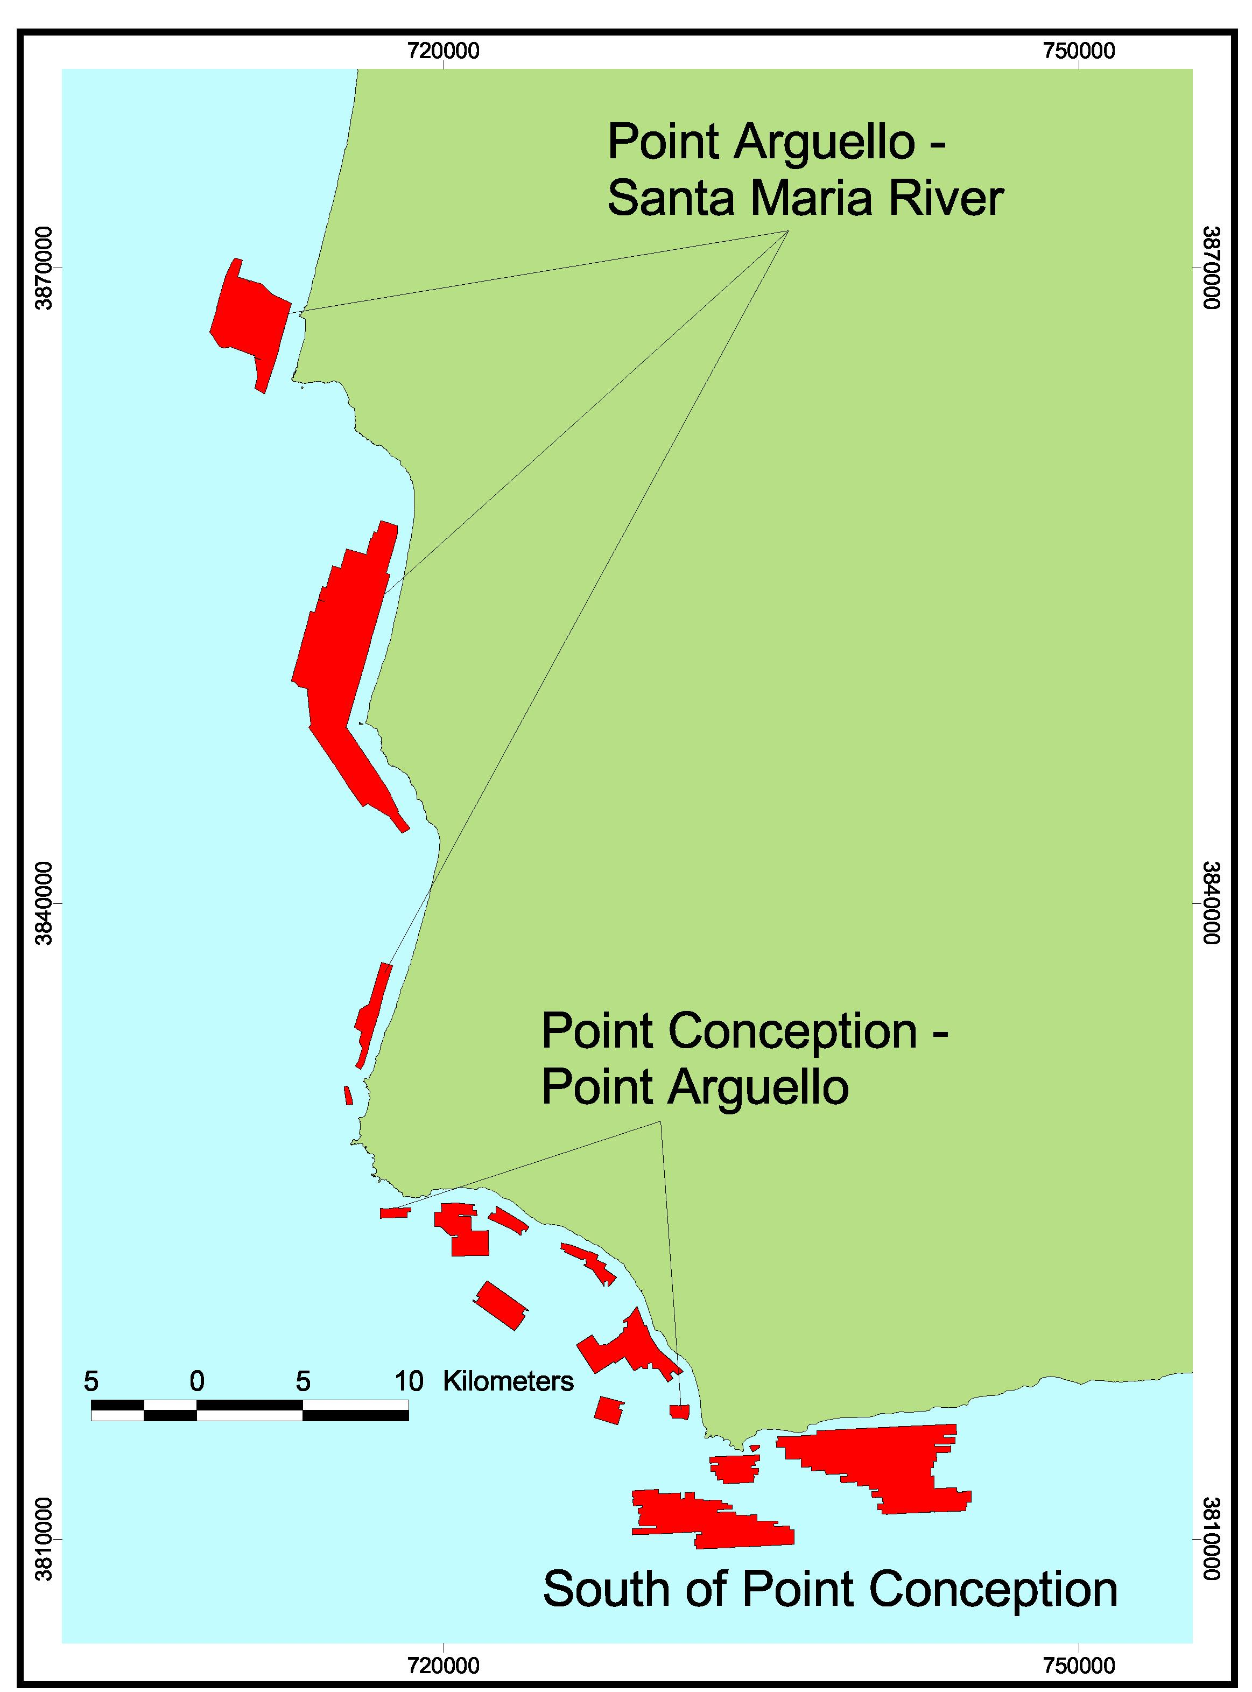
Footprint Map of Central Region A. All regions included in this volume were surveyed by industry using sidescan sonar imagery (red) and mapped by the Center for Habitat Studies.

